# CS 255 System Design Document Template

This template lays out all the different sections that you need to complete for Project Two. Each section has guidance to prompt your thinking. You will need to continually reference the interview transcript as you work to make sure that you are addressing your client’s needs. There is no required length for the final document. Instead the goal is to complete each section based on what your client’s needs are. Remove this note when you are finished, and replace all bracketed text with the relevant information.

## UML Diagrams

### UML Use Case Diagram

### UML Activity Diagrams

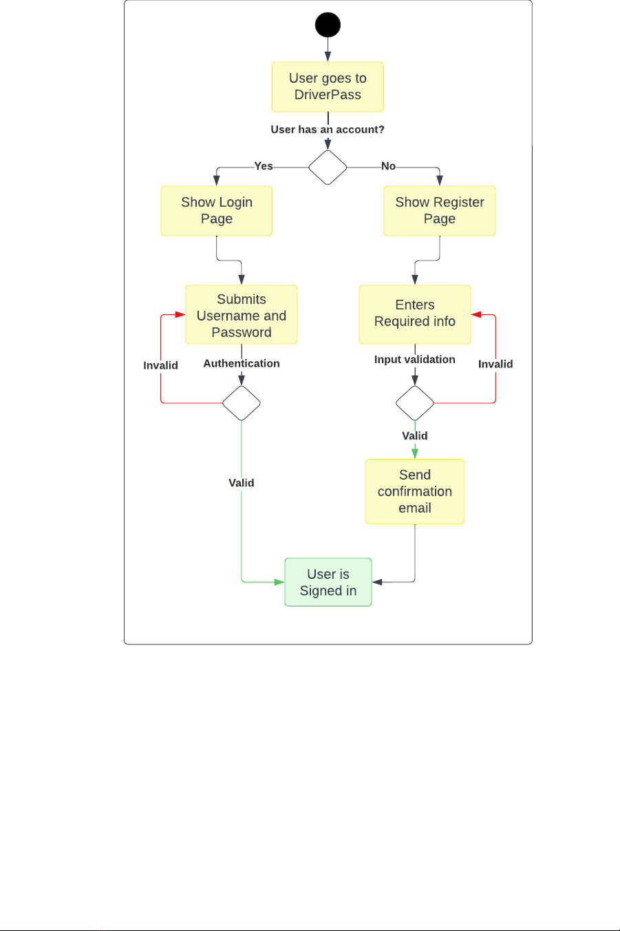

### UML Sequence Diagram

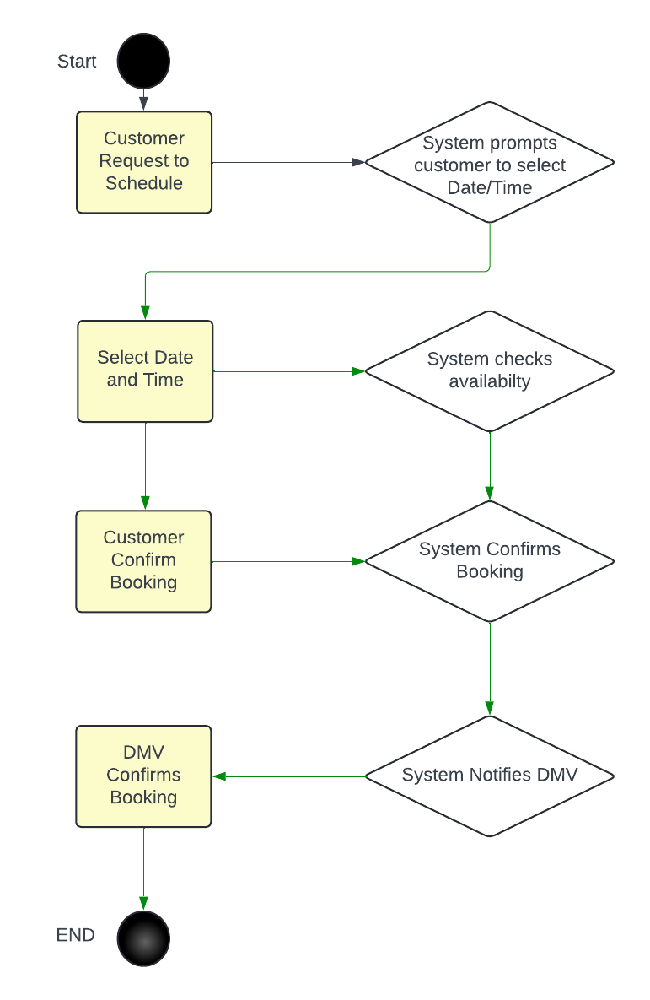

### UML Class Diagram

## Technical Requirements

Hardware Requirements:

1. Server Infrastructure: The system will require server hardware to host the web-based application. This includes sufficient processing power, memory, and storage capacity to handle user requests and data storage.
2. Network Equipment: Reliable networking equipment such as routers, switches, and firewalls will be needed to ensure seamless communication between clients and servers.
3. End-User Devices: The system should be accessible from a variety of end-user devices, including desktop computers, laptops, tablets, and smartphones. Therefore, compatibility with different device types and screen sizes should be considered.

Software Requirements:

1. Web Development Framework: A robust web development framework, such as Django, Ruby on Rails, or ASP.NET, will be required to build the web-based application.
2. Database Management System (DBMS): A DBMS, such as MySQL, PostgreSQL, or MongoDB, will be needed to store and manage user data, scheduling information, lesson progress, and other system-related data.
3. Programming Languages: Proficiency in programming languages such as HTML, CSS, JavaScript, and Python (or any other server-side language based on the chosen web development framework) will be essential for system development.
4. Integrated Development Environment (IDE): Developers will require an IDE like Visual Studio Code, PyCharm, or Sublime Text to write, test, and debug code efficiently.

Tools:

1. Version Control System: A version control system like Git will be necessary to manage code changes, collaborate with team members, and maintain a history of revisions.
2. Project Management Tools: Tools such as Jira, Trello, or Asana will facilitate project planning, task assignment, and progress tracking throughout the development lifecycle.
3. Testing Frameworks: Testing frameworks like Selenium, pytest, or Jasmine will be needed to automate testing processes and ensure software quality.

Infrastructure Requirements:

1. Cloud Hosting: Utilizing a cloud service provider like Amazon Web Services (AWS), Microsoft Azure, or Google Cloud Platform (GCP) will offer scalability, reliability, and flexibility in hosting the system.
2. Data Backup and Recovery: Implementing regular data backups and a disaster recovery plan will ensure data integrity and minimize downtime in case of system failures or data loss events.
3. Security Measures: Implementing security measures such as SSL/TLS encryption, firewalls, intrusion detection systems, and regular security audits will safeguard the system against cyber threats and unauthorized access.